# Et billede, der indeholder Elarbejde, kable, værktøj, Elektroteknik Indhold genereret af kunstig intelligens kan være forkert.Power distribution system

As outlined in the battery section, we chose to standardize the main power supply in our system at 12 volts. While 12V is suitable for most of the power-hungry components, it is not ideal for everything—especially not for sensitive electronics like the Arduino, the encoder, and various other low-voltage subsystems. To address this, and drawing on experience from motorsport and automotive wiring harness design, a power distribution system was implemented—similar in concept to what you’d find in a racing vehicle. Just like in a car, we introduced a centralized 12V power bus to act as the backbone of the system, from which we could step down to 5V and power everything cleanly and reliably. It might be a bit overkill for a prototype, but as anyone who's tried debugging spaghetti wiring will agree, having structured power management is never a bad idea.

The board shown in the image is connected directly to the battery (and yes, since the photo was taken, we’ve added a physical fuse for safety). It essentially uses a piece of veroboard as a simple power distribution bus, where all 12V components—such as the L298N motor driver, the compressor, and the magnetic solenoid valve—are connected. Upstream from the battery, you’ll also see our main 12V power source: a well-used USB-C Power Delivery (PD) board. This unit can output between 5V and 20V depending on its configuration, and we have it set up to deliver 12V at a maximum of 3A.

The PD board is primarily used to maintain the battery at around 80% charge during operation. Interestingly, this wasn’t an intentional feature, but a lucky accident—as it turns out, storing lithium batteries at around 80% charge is ideal for preserving their health over time. Because the PD board is limited to 3A, the battery itself is responsible for supplying the bulk of the system’s current demand. Our system is capable of drawing up to 12A at peak (see the pressure tank report and motor specifications for details).

While this isn’t a perfect power setup, it’s a practical and safe solution for a prototype that needs to be mobile and untethered from wall power. A wired 12V mains supply might have been more stable, but would’ve added both complexity and risk—something we wanted to avoid for this stage of development

After the 12V power distribution board, we use a DC-DC buck converter to step the voltage down to 5V. It’s one of those classic LM2596-based converters you can find pretty much everywhere online—cheap, reliable, and surprisingly robust for what it costs. The LM2596 is a step-down regulator capable of handling input voltages up to 40V and outputting a steady, adjustable lower voltage, which in our case is 5V. We use it to supply power to all the low-voltage components in the system, like the Arduino, encoder, and various sensors.

One of the reasons this converter is such a common sight in hobbyist and prototyping builds is its built-in safety features. It has both thermal shutdown and short-circuit protection, which gives some peace of mind when testing or quickly rewiring parts of the circuit. While it’s far from a high-end power module, its availability and simplicity made it the obvious choice for our project.

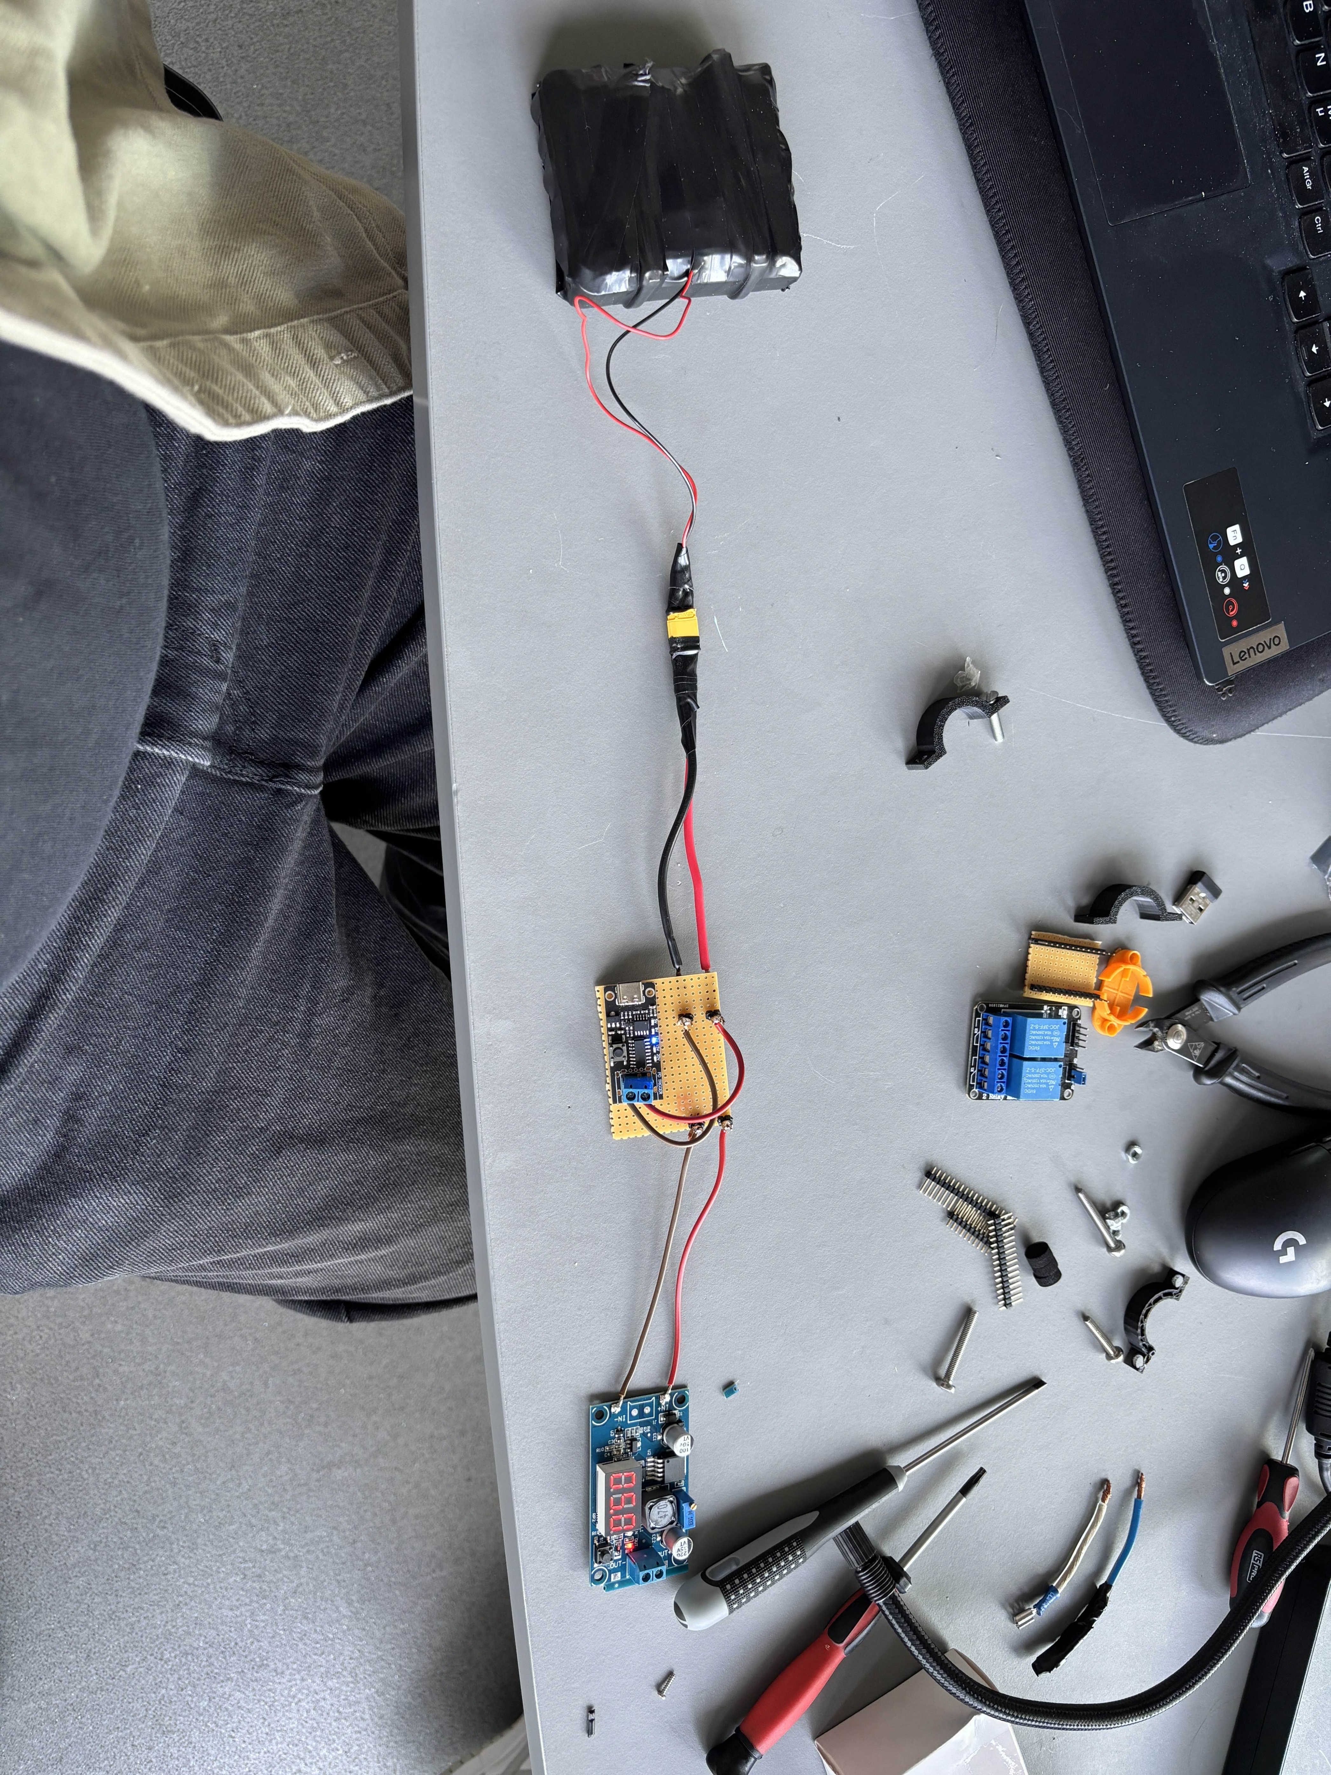

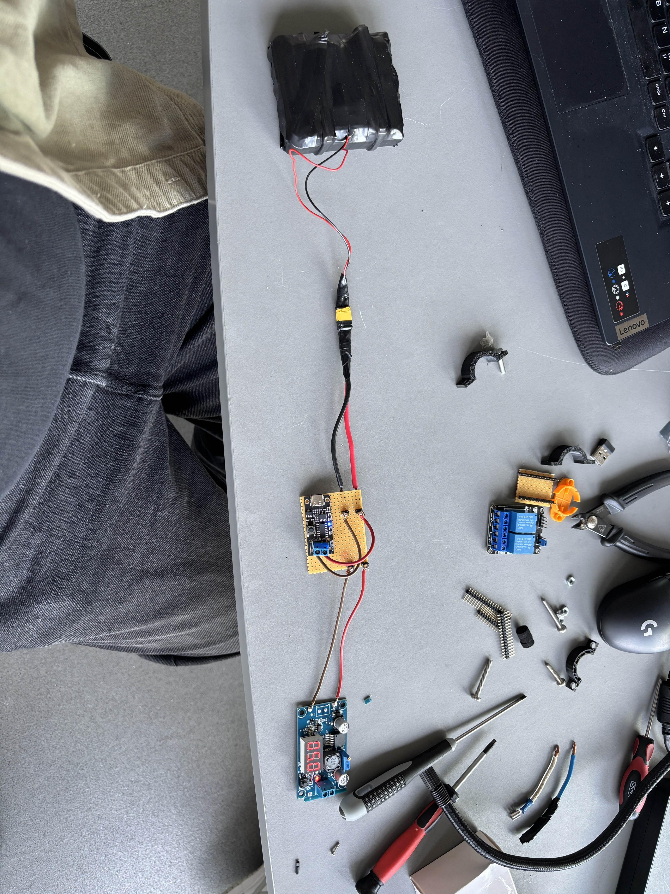This provided all our 5V supply, using another power distribution board (the one you see below)

Using this board made both testing and final assembly significantly easier. Having a dedicated 5V and ground rail available simplified the wiring process, especially since it shared a common ground with the 12V supply. This allowed us to keep all components referenced to the same ground potential, which—at least in theory—should have made everything more stable and predictable.

However, issues began to appear during late-stage testing, particularly when the Arduino was no longer connected to a computer. These tests revealed that the ground connection wasn’t as solid as we initially assumed. What seemed like a clean and logical setup at the time turned out to have potential grounding issues that likely impacted stability in the standalone configuration.

This grounding issue directly affected the Y-axis control, where we used a potentiometer for position feedback. Due to the inconsistent ground reference, the readings from the potentiometer became unreliable, causing the Y-axis to move in unintended directions—often forcing the mechanism into the base instead of the intended travel direction. This was not only difficult to identify as the root cause, but also proved time-consuming to resolve. It highlighted the importance of a stable and unified ground reference throughout the system, especially when dealing with analog signals and position-sensitive components.